Start Application in Preview Mode.
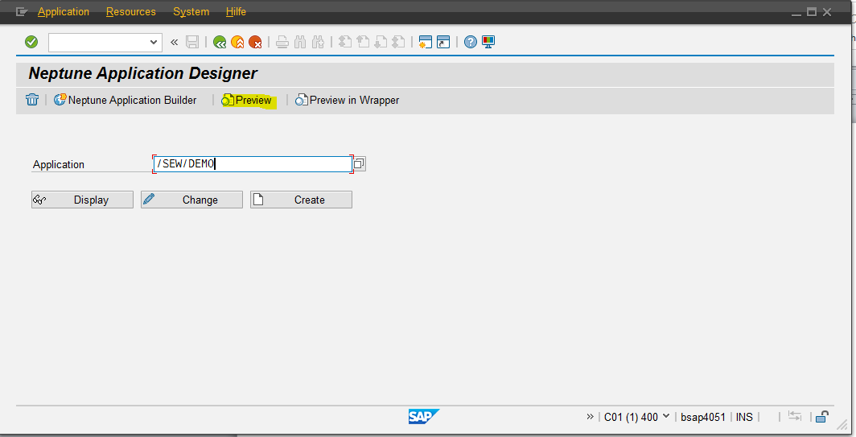
Providing the Authority - Details:
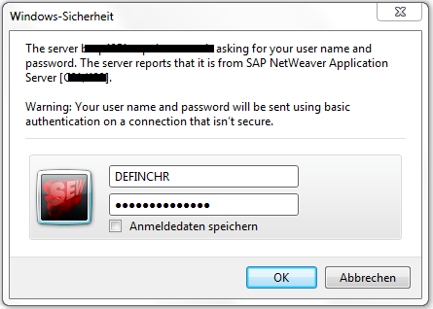

The result is an empty page.

Display Developer Tools (F12)
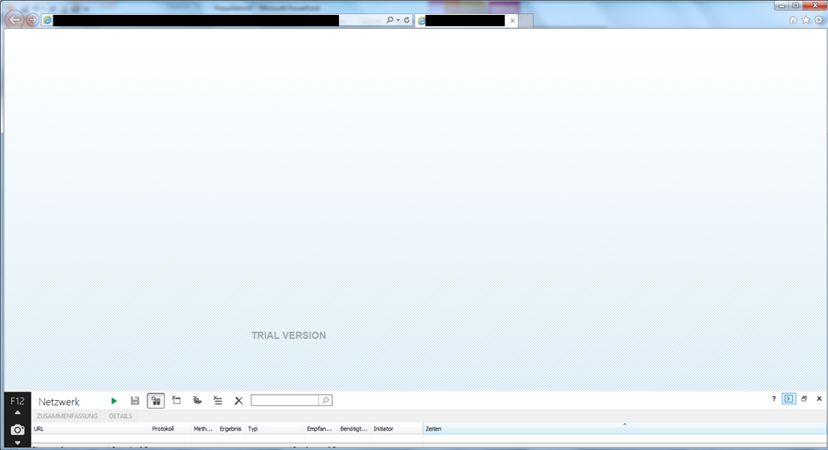
And refresh:
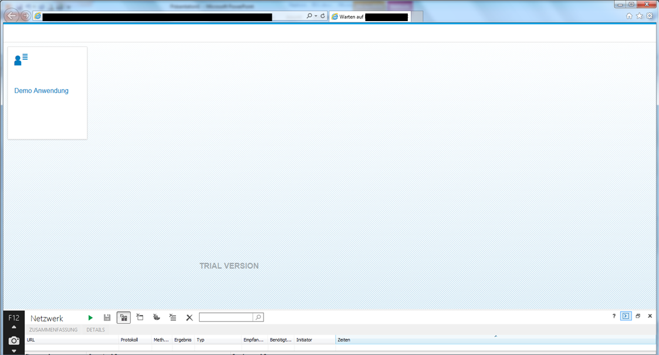
Now the app works – I could also hide the developer tools again. As long as the session is valid – the app works. Refreshing before showing the developer tools does not work.

