HOW TO USE THEME DESIGNER
Step-1
Execute UI5 Theme Designer tcode
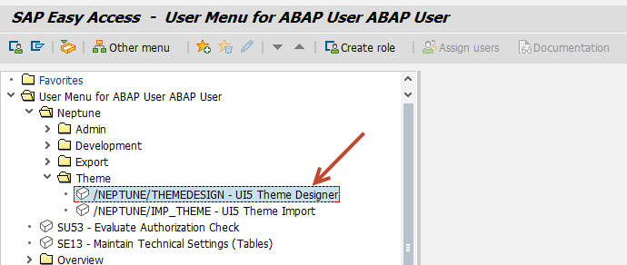

Step-2
Browser will pops up and leads to theme designer developing environment.
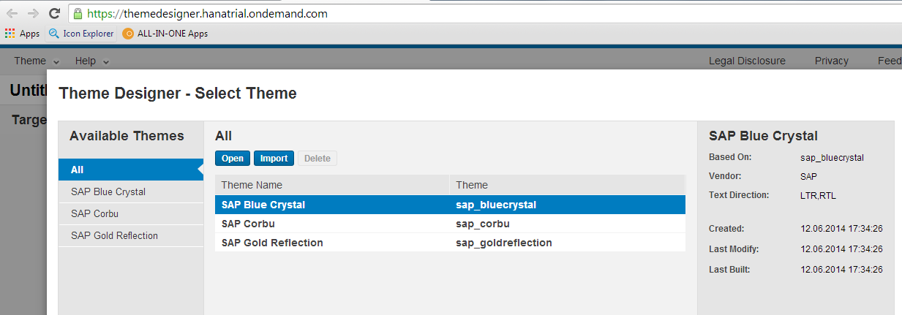

Step-3
Select any of these themes, here I have selected SAP BLUE Crystal
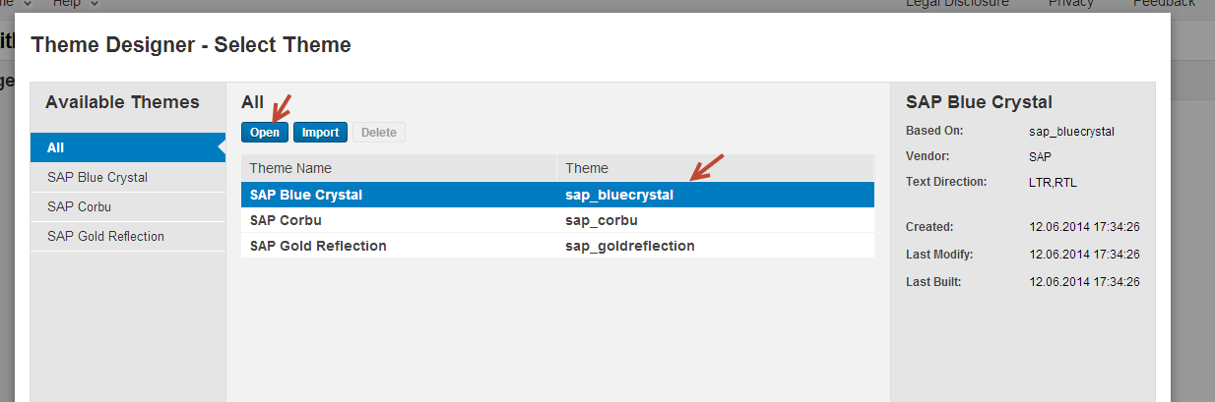

Step-4
You will see the below screen.
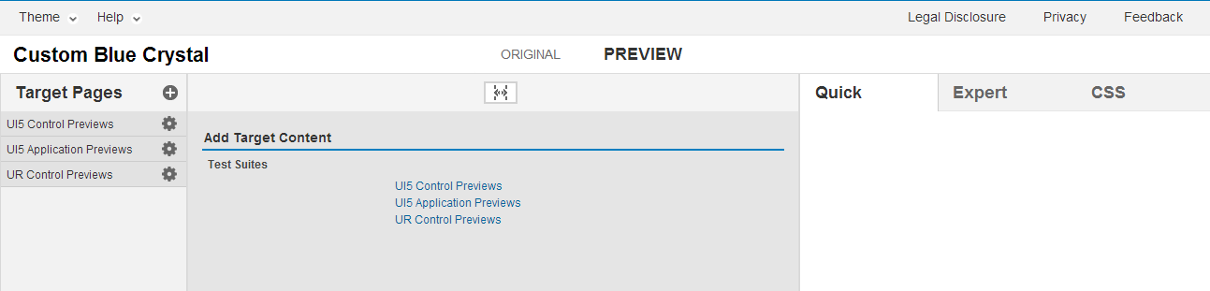
Select any of these Previews to change the themes. Here I have selected UI5 Application Previews
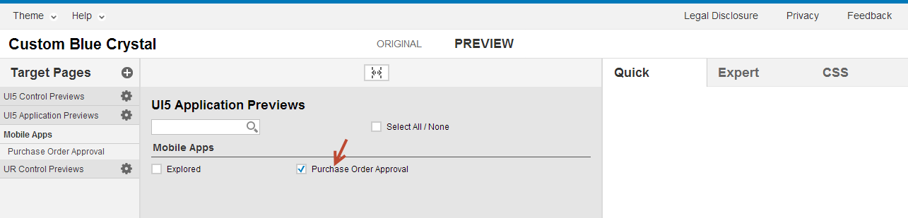

Step-5
Double Click on the Purchase Order Approval on left pane
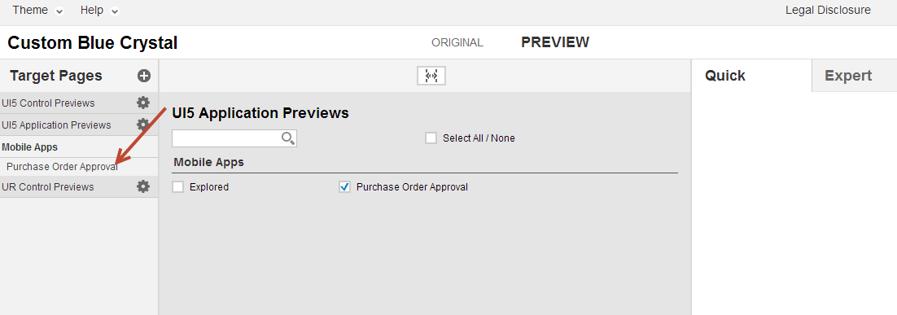
Now you will see the sample mobile application preview.
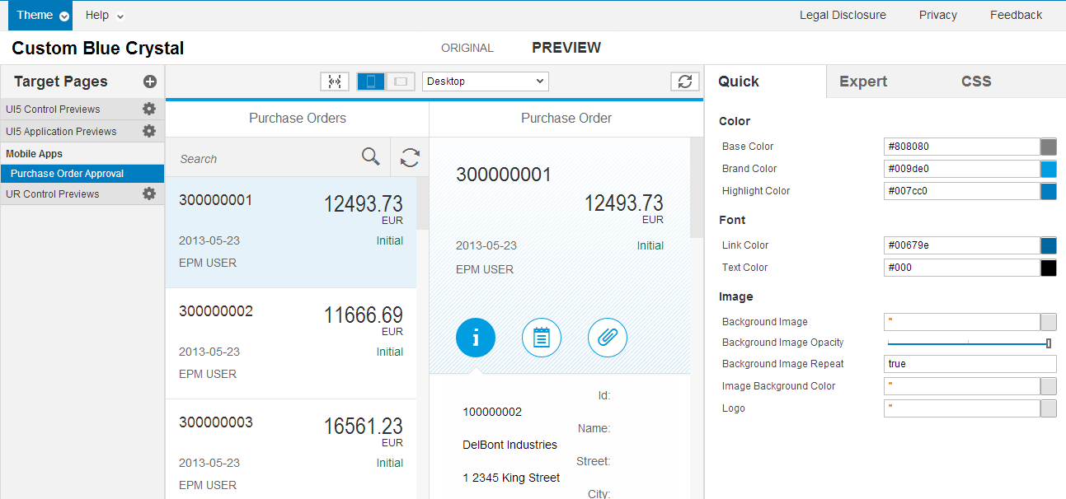

Step-6
Here you can change the theme color by using the right side pane.
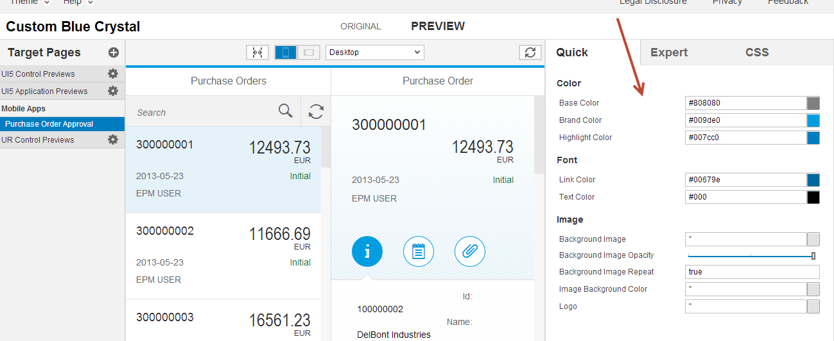
I have changed the brand color to red
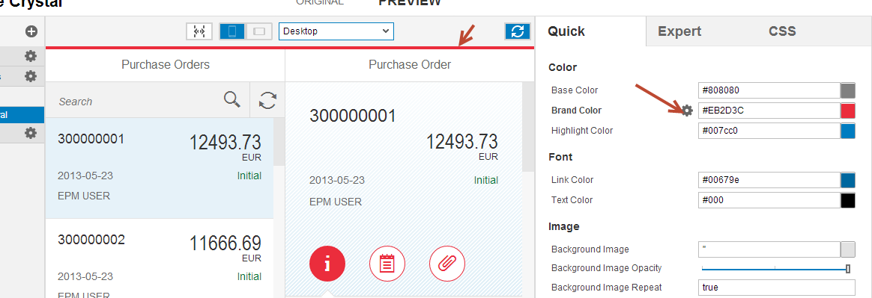

Step-7
Now Click on Export to export the theme to Neptune Application Designer. Once you exported a zip will be downloaded.
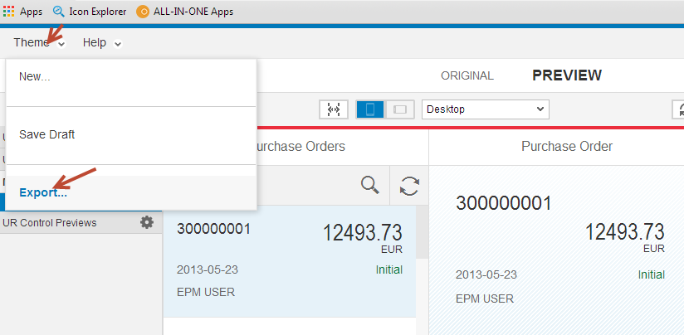
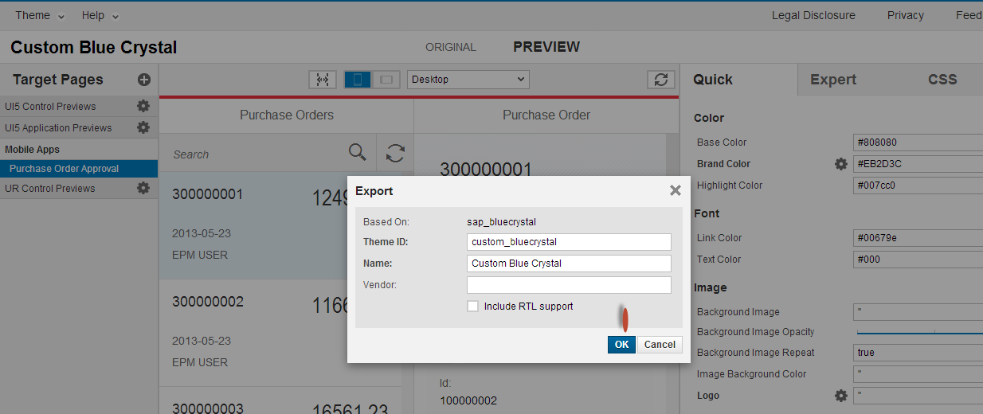

Step-8
Unzip the downloaded file to a folder and Execute Import theme designer tcode
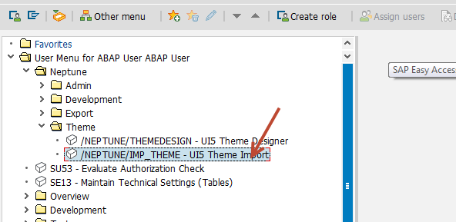
Provide the file path where you have unzipped and click on F8
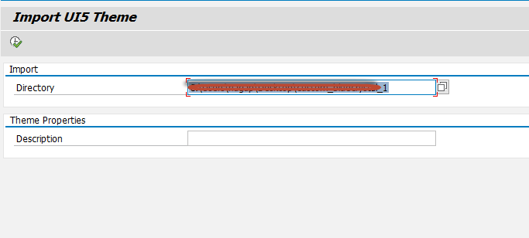

In NEPTUNE Application Designer
New these newly imported theme will be available for the all the application in NAD.
