The idea is to choose the plants we want to set as default and on pressing the ‘SAVE’ button; the data for tables on other pages should be reselected only for these plants.
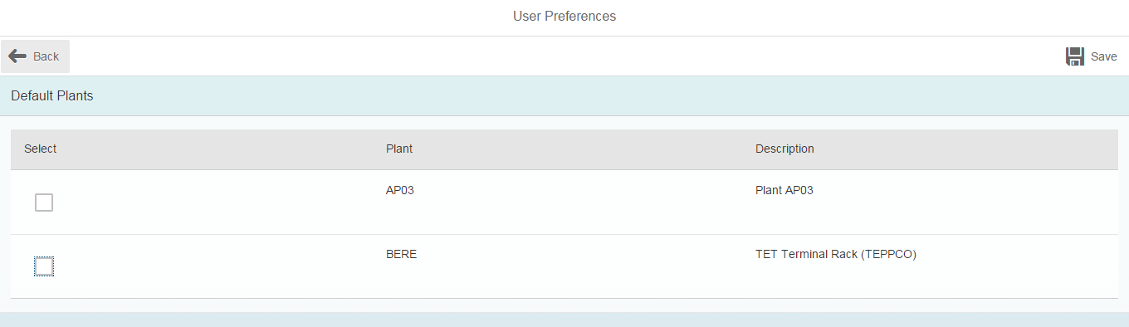
Offline data model is selected in the settings for the app:
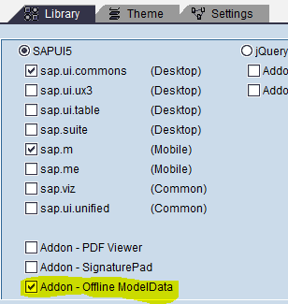
Neptune designer view of the page:
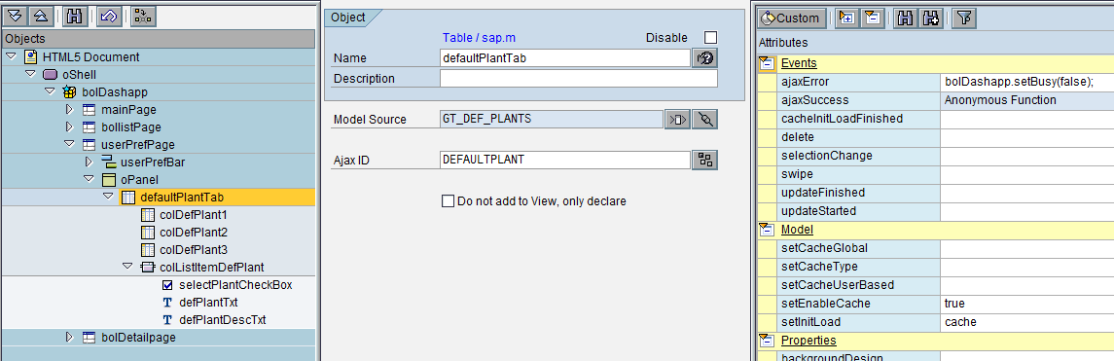

Structure of Model Source GT_DEF_PLANTS:
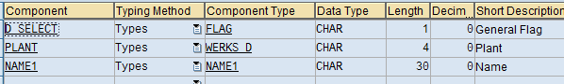
Select event JS for checkbox:
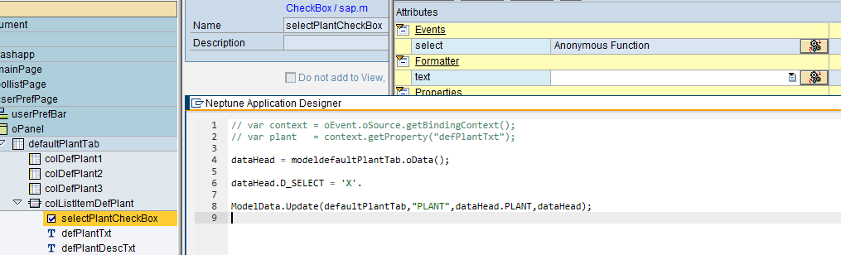
Save button:
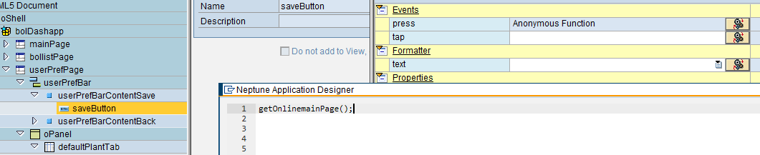

mainPage Ajax communication set up:
