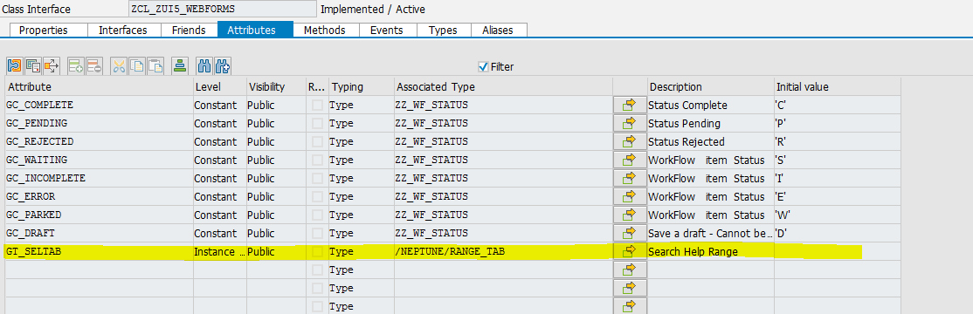
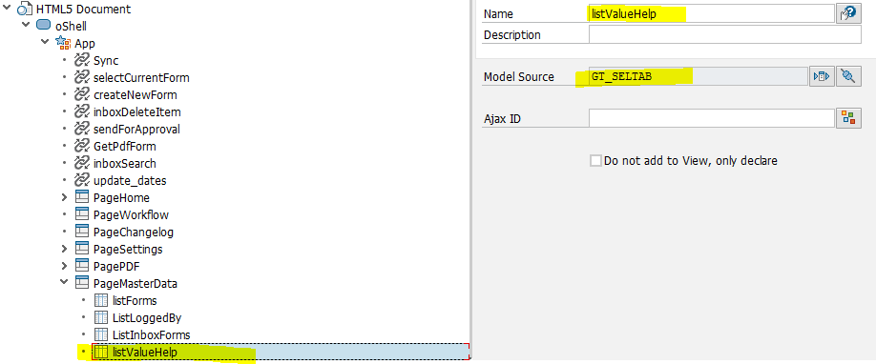
modelF4tabSelection.setData(modellistValueHelp.oData); //Sap.m.list model source

if (modelF4tabSelection.oData.length) {
F4ButSelection.setText("Conditions (" + modelF4tabSelection.oData.length + ")");
} else {
F4ButSelection.setText("Conditions (0)");
}

modelF4tabResult.setData({});

F4toolResultLabel.setText("Items (0)");
F4ButSelection.setEnabled(false);
F4tabResult.setMode("SingleSelect");
F4ButSelection.setVisible(true);
F4ButSelAll.setVisible(true);

F4Dialog.open();

F4App.to("F4PageSelection", "show");

getOnlineF4SearchHelps("MAT1:inMAT1");

