System Message does not show up as usual since upgrade to 4.0

Correct message show not running in Launchpad 4.0.
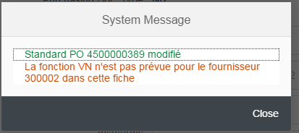
- Apps has been adapated to run on Neptune UIX 4.0
- Running Launchpad 4.0 on Chrome Version 49.0.2623.110 m
- Attributes of Dialog

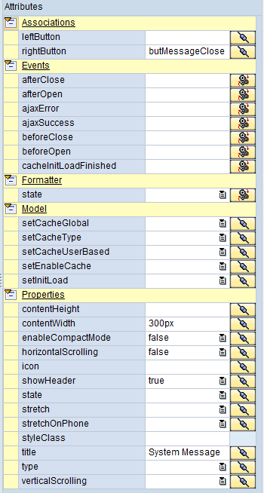

Attributes of MessageArea
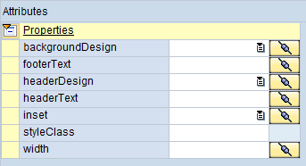

As you can see messages are not aligned correctly and parts are missing.
