That is the new App
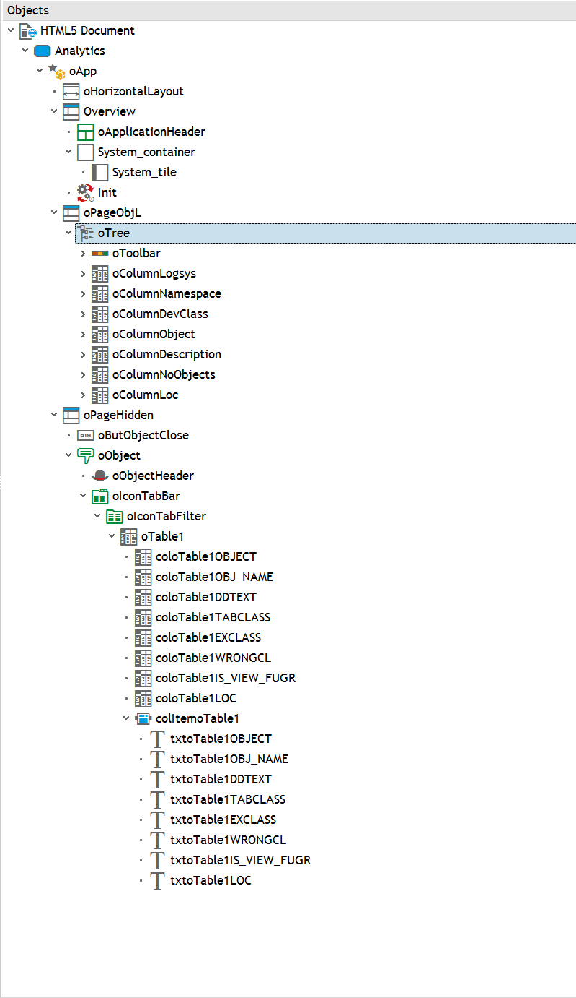

This is the first Page:
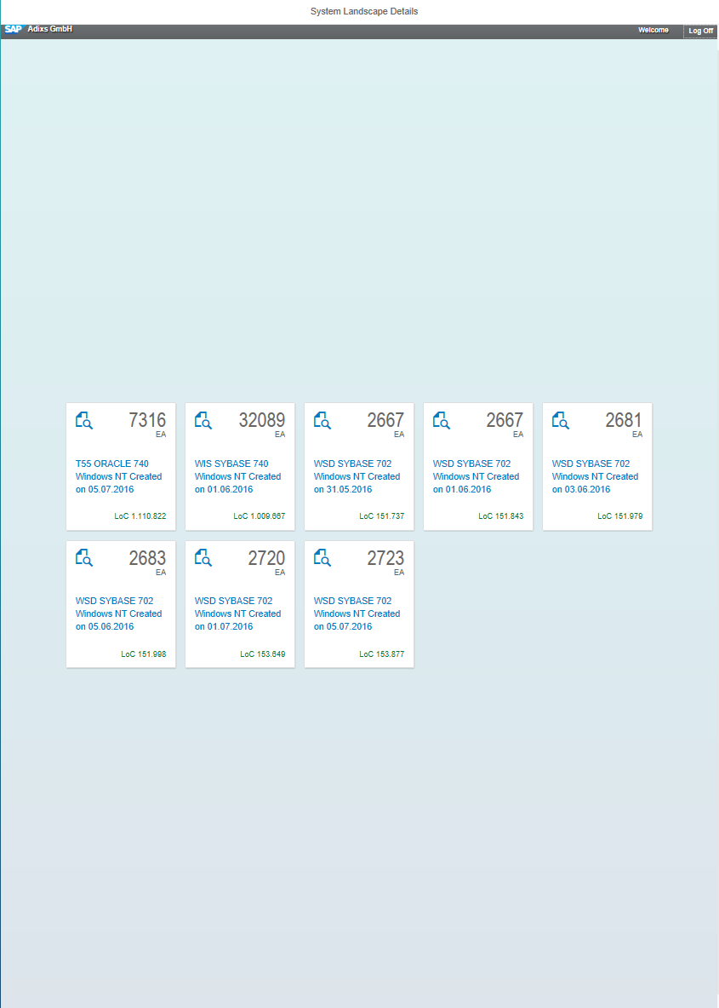
(we already did the logic on this one and it works fine – also in the other app)
Press tile will fire this
var context = oEvent.oSource.getBindingContext();
var object = context.getProperty("OBJECT");
var method = context.getProperty("METHOD");
var parameter = context.getProperty("PARAMETER");
var clickedTile = context.getProperty("OBJECT");
sap.ui.core.BusyIndicator.show();
if (clickedTile !== lastTile){

getOnlineoTree(clickedTile);
lastTile = clickedTile;
}

else{
oApp.to(oPageObjL);
lastTile = clickedTile;
}

if (method === '') {
eval(object);
} else {
var obj = window[object];
obj[method](parameter);
}

Now based on the Tile Clocked:
I read all the data for this system and convert it to IT_DATA for the TableTree.
METHOD build_tree.
DATA: ls_tree TYPE /neptune/lib_tre,
ls_object_tree TYPE /neptune/sapui5_tree,
it_icon TYPE STANDARD TABLE OF icon,
ls_icon TYPE icon.
DATA: lt_result TYPE /wcp/analysis_results_t.
DATA: lv_guid TYPE /wcp/ana_hd-guid.
DATA: lv_requested_stats TYPE string.
DATA: lv_identifier TYPE string.
DATA: lv_identifier1 TYPE string.
DATA: lt_level1 TYPE /wcp/fi_obj_summary_t.
DATA: lt_level2 TYPE /wcp/fi_obj_summary_t.
DATA: lt_level3 TYPE /wcp/fi_obj_summary_t.
DATA: lt_level4 TYPE /wcp/fi_obj_summary_t.
DATA: lt_aggregate TYPE /wcp/global_objects_t.
DATA: lo_handler TYPE REF TO /wcp/cl_analytics_handler.
FIELD-SYMBOLS: <ls_object> TYPE /wcp/r_nobjcl_s.
FIELD-SYMBOLS: <ls_result> TYPE /wcp/analysis_results_s.
FIELD-SYMBOLS: <ls_devclass> TYPE /wcp/c_devclass_alv_s.
FIELD-SYMBOLS: <ls_namespace> TYPE /wcp/c_namespace_alv_s.
FIELD-SYMBOLS: <ls_tree> TYPE /wcp/fi_obj_summary_s.
FIELD-SYMBOLS: <ls_object_type> TYPE /wcp/objct_type_alv_s.
SPLIT iv_ajax_value AT ':' INTO lv_guid --- the GUID comes from the tile
lv_identifier1.
TRY.
/wcp/cl_db_analytics=>get_result(
EXPORTING
iv_guid = lv_guid
CHANGING
ct_result = lt_result <- this I would like to keep cannot see how ?
).
CATCH /wcp/cx_analytics.
RETURN.
ENDTRY.
READ TABLE lt_result INDEX 1 ASSIGNING <ls_result>.
CHECK sy-subrc EQ 0.
CREATE OBJECT lo_handler.
lo_handler->aggregate_objects( EXPORTING iv_logsys = <ls_result>-logsys
it_table = <ls_result>-objects
CHANGING ct_table = lt_aggregate ).
*------------------------------------------------------------------------*
* BUILD DATA
*------------------------------------------------------------------------*
REFRESH mt_data. --- The Tree Internal Table
* Build Tree
APPEND INITIAL LINE TO lt_level1 ASSIGNING <ls_tree>.
<ls_tree>-key = <ls_result>-logsys. <-this the Key field im gone get for each level
<ls_tree>-logsys = <ls_result>-logsys.
<ls_tree>-text = <ls_result>-text.
LOOP AT <ls_result>-namespaces ASSIGNING <ls_namespace>.
APPEND INITIAL LINE TO lt_level2 ASSIGNING <ls_tree>.
<ls_tree>-parent = <ls_result>-logsys.
<ls_tree>-key = 'NSP' && ':' && <ls_result>-logsys && ':' && <ls_namespace>-namespace && ':' && ' ' && ':' && ' '.
<ls_tree>-namespace = <ls_namespace>-namespace.
<ls_tree>-logsys = <ls_result>-logsys.
<ls_tree>-text = <ls_namespace>-descriptn.
<ls_tree>-no_obj = <ls_namespace>-cnt_objects.
<ls_tree>-no_loc = <ls_namespace>-loc.
LOOP AT <ls_result>-devclasses ASSIGNING <ls_devclass> WHERE namespace = <ls_namespace>-namespace.
APPEND INITIAL LINE TO lt_level3 ASSIGNING <ls_tree>.
<ls_tree>-parent = 'NSP' && ':' && <ls_result>-logsys && ':' && <ls_namespace>-namespace && ':' && ' ' && ':' && ' '.
<ls_tree>-key = 'DEV' && ':' && <ls_result>-logsys && ':' && <ls_namespace>-namespace && <ls_devclass>-devclass && ':' && ' ' .
<ls_tree>-namespace = <ls_namespace>-namespace.
<ls_tree>-logsys = <ls_result>-logsys.
<ls_tree>-devclass = <ls_devclass>-devclass.
<ls_tree>-no_obj = <ls_devclass>-cnt_objects.
<ls_tree>-no_loc = <ls_devclass>-loc.
<ls_tree>-text = <ls_devclass>-text.
LOOP AT <ls_result>-object_types ASSIGNING <ls_object_type>
WHERE namespace = <ls_namespace>-namespace
AND devclass = <ls_devclass>-devclass.
APPEND INITIAL LINE TO lt_level4 ASSIGNING <ls_tree>.
<ls_tree>-parent = 'DEV' && ':' && <ls_result>-logsys && ':' && <ls_namespace>-namespace && <ls_devclass>-devclass && ':' && ' ' .
<ls_tree>-key = 'OBT' && ':' && <ls_result>-logsys && ':' && <ls_namespace>-namespace && ':' && <ls_devclass>-devclass && ':' && <ls_object_type>-object.
<ls_tree>-namespace = <ls_namespace>-namespace.
<ls_tree>-logsys = <ls_result>-logsys.
<ls_tree>-devclass = <ls_devclass>-devclass.
<ls_tree>-object = <ls_object_type>-object.
<ls_tree>-no_obj = <ls_object_type>-cnt_objects.
<ls_tree>-no_loc = <ls_object_type>-loc.
<ls_tree>-text = <ls_object_type>-text.
ENDLOOP.
ENDLOOP.
ENDLOOP.

Filling up the internal table
APPEND LINES OF lt_level1 TO mt_data.
APPEND LINES OF lt_level2 TO mt_data.
APPEND LINES OF lt_level3 TO mt_data.
APPEND LINES OF lt_level4 TO mt_data.
ENDMETHOD. "BUILD_TREE

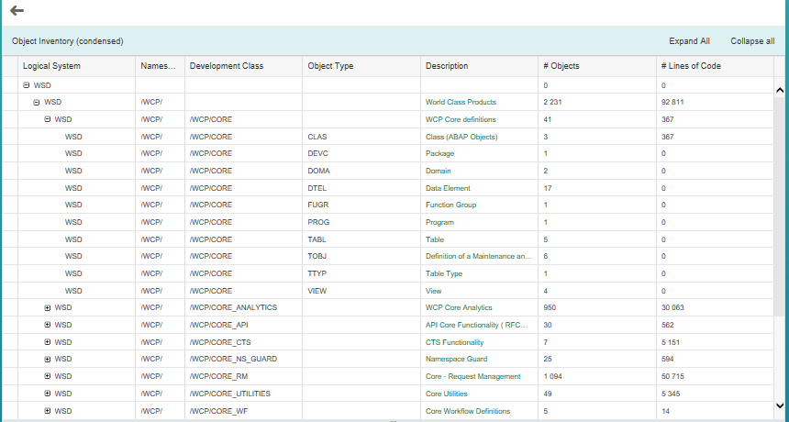
That works fine too. Now starts the Problem. The selectRow is not the problem anymore - because with this row I get the field KEY and fire the ajax event of course when the server side method is executed I need to know which system it was (clicked Tile which is actually a guid. Without the guid I cannot do anything – but on this page already all data were read but it is gone when I go to oObject – popup screen. When I go back from the pop-up everything is gone.

Page on1: file table MT_TILE
Press event for Page 2.
That event will read a large amount of Data and aggregates it to the PageTwo -as you can see – very fast and very slick.

var context = this.getContextByIndex(this.getSelectedIndex());
var value = modeloTree.getProperty("KEY", context);
getOnlineoTable1(value);

So the question is should I do a lot of hidden pages where I bind a global structure read and fire the next event ? Is that the way to go – but the IT_data would not be resolved because I loose ? As I said before is the get/set Cache an appropriate way.

I hope I do not confuse you too much.

