Change 1

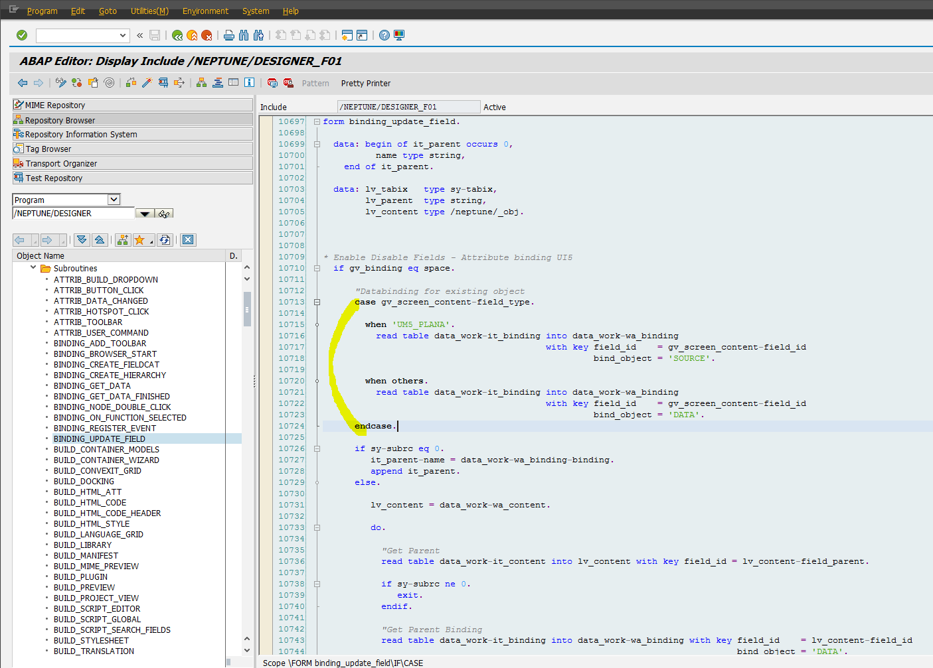

Code:
"Databinding for existing object
case gv_screen_content-field_type.
when 'UM5_PLANA'.
read table data_work-it_binding into data_work-wa_binding
with key field_id = gv_screen_content-field_id
bind_object = 'SOURCE'.
when others.
read table data_work-it_binding into data_work-wa_binding
with key field_id = gv_screen_content-field_id
bind_object = 'DATA'.
endcase.

Change 2

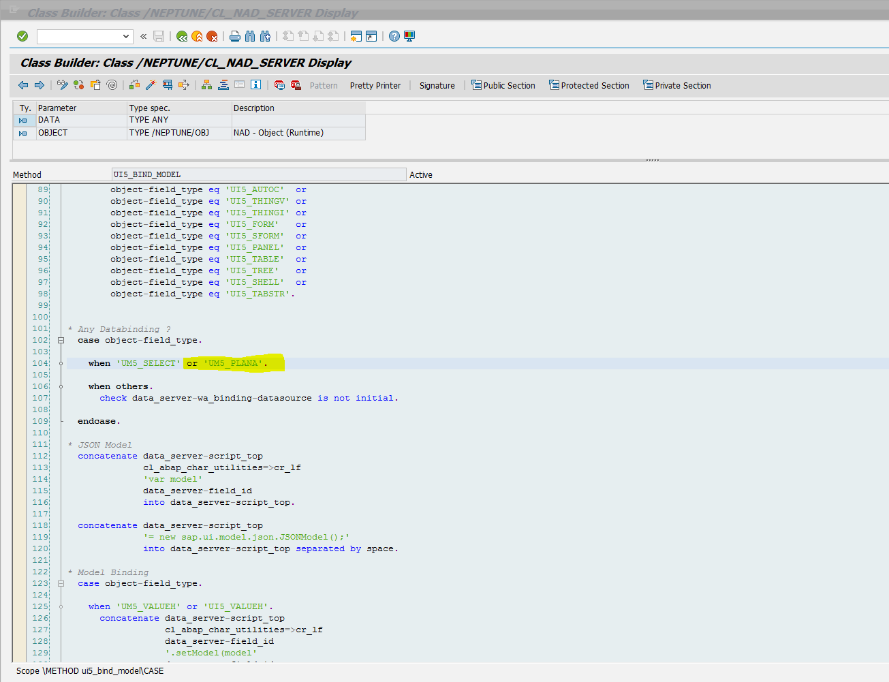

Change 3

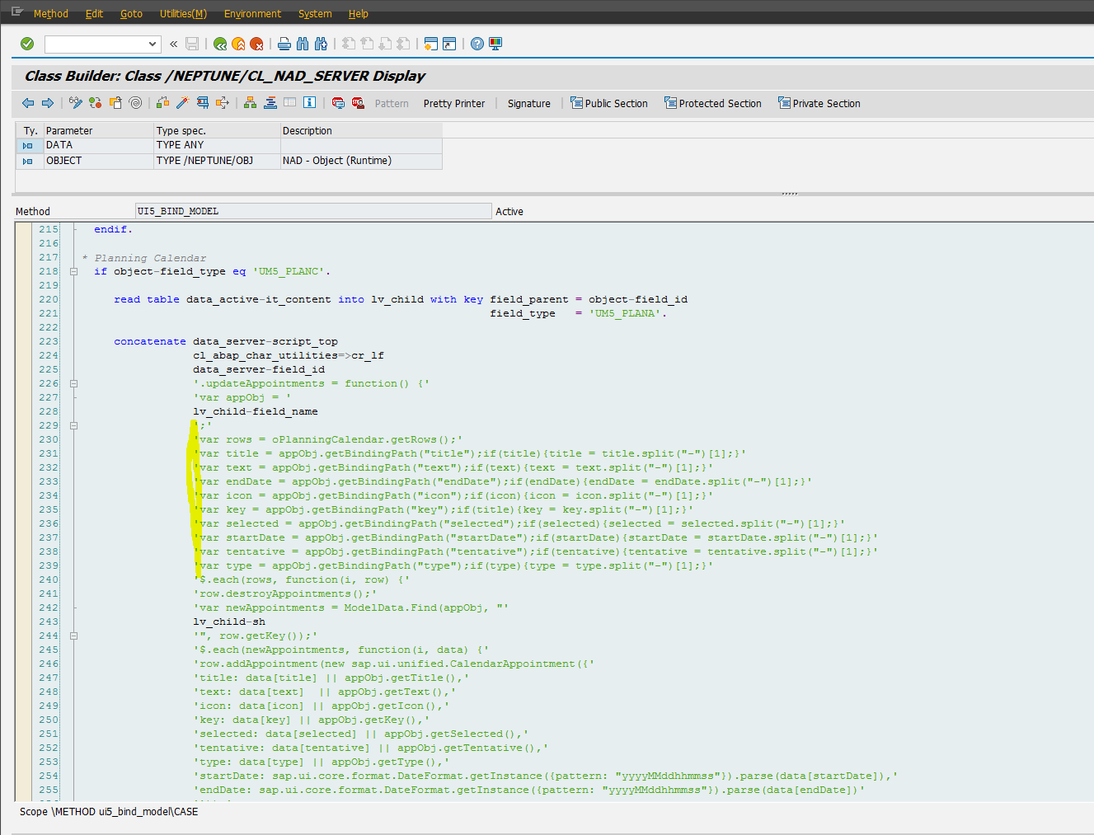
Code
'var title = appObj.getBindingPath("title");if(title){title = title.split("-")[1];}'
'var text = appObj.getBindingPath("text");if(text){text = text.split("-")[1];}'
'var endDate = appObj.getBindingPath("endDate");if(endDate){endDate = endDate.split("-")[1];}'
'var icon = appObj.getBindingPath("icon");if(icon){icon = icon.split("-")[1];}'
'var key = appObj.getBindingPath("key");if(title){key = key.split("-")[1];}'
'var selected = appObj.getBindingPath("selected");if(selected){selected = selected.split("-")[1];}'
'var startDate = appObj.getBindingPath("startDate");if(startDate){startDate = startDate.split("-")[1];}'
'var tentative = appObj.getBindingPath("tentative");if(tentative){tentative = tentative.split("-")[1];}'
'var type = appObj.getBindingPath("type");if(type){type = type.split("-")[1];}'

Change 4

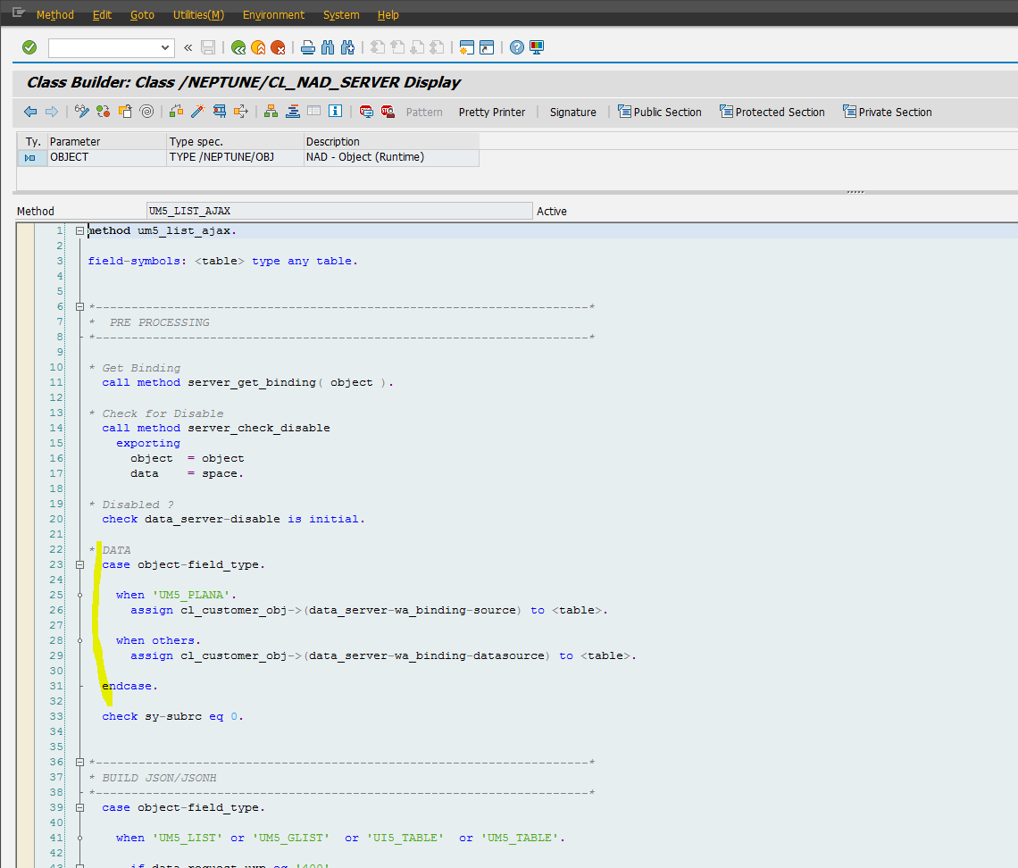
Code

case object-field_type.
when 'UM5_PLANA'.
assign cl_customer_obj->(data_server-wa_binding-source) to <table>.
when others.
assign cl_customer_obj->(data_server-wa_binding-datasource) to <table>.
endcase.

