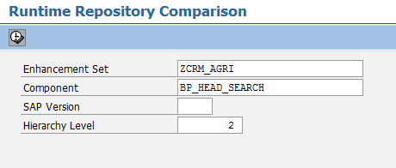
Transaction WCF_RT_COMP
Collisions or items that need review are highlighted to the developer.
