When I access my Bundle with RSS TILE via browser, I have the following error message
Cannot load tile. By checking the Network resource on Chrome dev tools,
I see that RSS feed (www.gartner.com/newsroom/rss ) is a mixed-content so locked by default from chrome browser.

By clicking on the shield icon 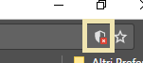 I allow browser to load “not secure” scripts
So, I reload the bundle page (F5) and all the resources is correctly loaded, but the RSS TILE still show the message “cannot load tile”.

I don’t have any problem to access this resource from my browser, in fact I can access directly to http://www.gartner.com/newsroom/rss, so not firewall/network issues.
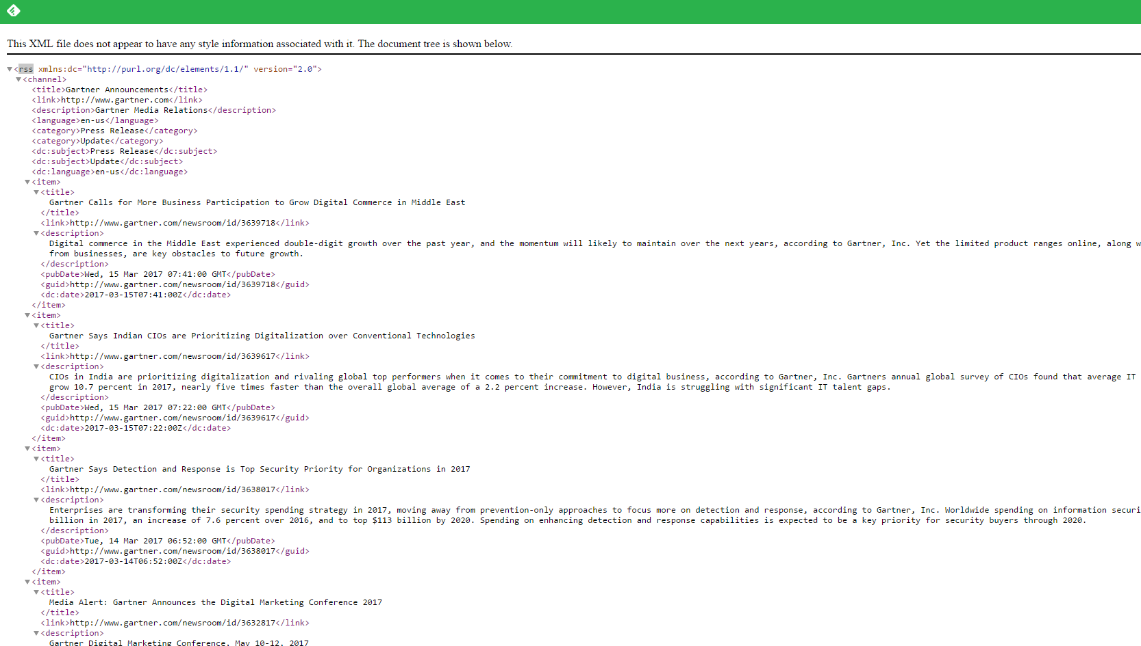
The same happens if I try to load an “internal RSS TILE” as suggestion in the topic discussion

This is the configuration done in NAM for bundle:
